## TERM-1 Comptia A+ N+ Assignment

#### Module 3 [Network Configuration]

**Topic: Local area networking**

##### **Assignment level Basic:**

1. What is Network?

* A computer network is a system that connects numerous independent computers in order to share information (data) and resources.

1. What is Internet & Intranet?

* The Internet is a global computer network that allows for information exchange between devices. An intranet is a private network that is only accessible to members of an organization.

##### **Assignment level Intermediate:**

1. How many types of Network we used?

* Mainly there are three types of computer networks: LAN(Local Area Network), WAN(Wide Area Network) and MAN(Metropolitan Area Network).

1. Different between LAN & PAN?

* A PAN connects the devices within the short range of an individual person, whereas a LAN connects devices at a single site, typically an office building.

##### **Assignment level advance:**

1. Explain LAN?

* A collection of devices connected together in one physical location, such as a building, office, or home.

1. What are different types of LAN devices?

* A network connection device, such as a router, hub, switch, wireless access point (WAP), gateway or bridge.

#### Topic: configured Network

##### **Assignment Level Basic**

1. What is configured network?

* Network configuration focuses on managing a network and its devices by applying the right set of policies, controls, and configurations. It encompasses activities from device discovery to configuration backups for efficient network administration.

1. How do we configure network?

* Network configuration is the process of assigning network settings, policies, flows, and controls.

##### **Assignment level Intermediate.**

1. How to check the ip address?

* On the taskbar, select the **Ethernet network** icon > the Ethernet network connection.

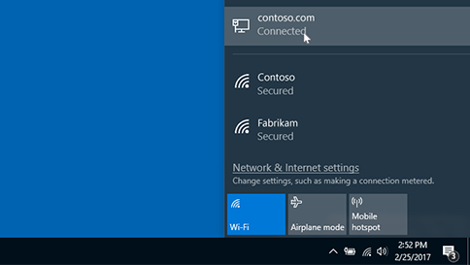

Under **Ethernet,** select the Ethernet network connection.

Under **Properties,** look for your IP address listed next to **IPv4 address.**

1. How to check the ip address through cmd?

* First, click on your **Start Menu** and type **cmd** in the search box and press enter.  
  A black and white window will open where you will **type ipconfig /all and press enter.**  
  There is a space between the command **ipconfig** and the switch of **/al**l.

Your ip address will be the **IPv4** address.

1. How can we enter static address in network adapter?

## 1.Access the Control Panel

In the Windows search bar, type in “ncpa.cpl” and then press enter.

Access the Control Panel

If you are not using Windows 10, follow the steps below instead.

A. On your keyboard, press the “Windows” and “R” keys at the same time.

B. Enter “ncpa.cpl” in the window that pops up.

Note: Network connections will display the network adapters that are currently connected to your computer.

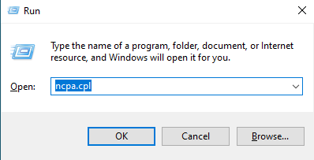

## 2. Select the Network Adapter

Right click on the network adapter that is currently connected to the device that you are trying to configure. Usually, it

will be the adapter with the word “Ethernet” in the name.

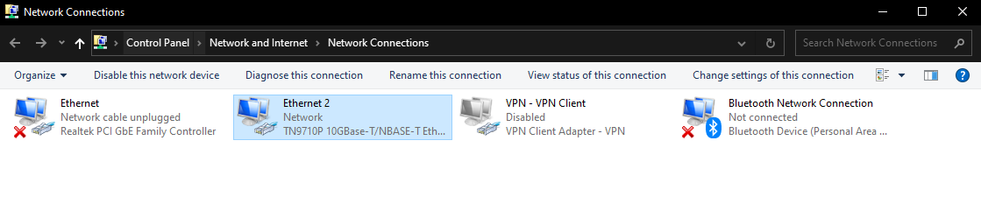

## 3. Select Properties

Select “Properties” from the drop-down menu.

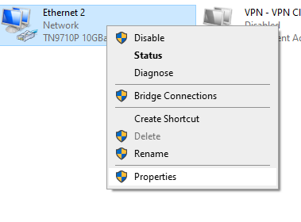

## 4. Select Internet Protocol Version 4 (TCP/IPv4)

Double-click on “Internet Protocol Version 4 (TCP/IPv4)”.

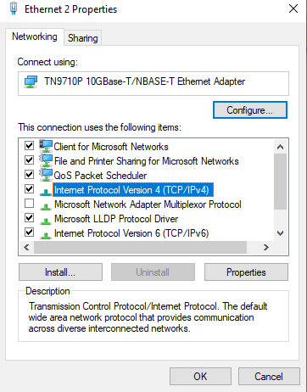

## 5. Manually enter IP address and subnet mask

Select “Use the following IP Address” and then input the following information in the corresponding fields:

IP address: Check the device that you are connected to in order to locate the IP address. The first three sets of digits

should match. For this tutorial, we will use IP address 192.168.10.10.

Subnet mask: The subnet mask between the device that you are trying to connect to needs to be the same as your PC.

For this tutorial, we will use subnet mask 255.255.255.0

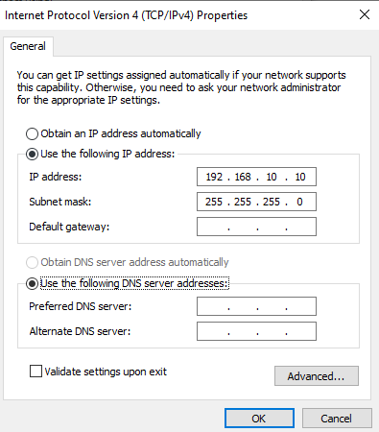

## 6. Save Settings

Click the OK button on “Internet Protocol Version 4 (TCP/IPv4) Properties” window, and also click the OK button on

“Ethernet Properties” window.

Note: The OK buttons must be clicked in both instances or your settings will not be saved.

## 7. Revert Back to DHCP

To set your computer back to DHCP, repeat steps 1-4 again. When you get to the “Internet Protocol Version 4

(TCP/IPv4) Properties” window, click “Obtain an IP address automatically”. This will allow your PC to be assigned a

random IP address on your network.

Note: The OK buttons must be clicked in both instances or your settings will not be saved.

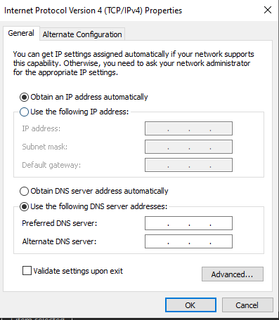

##### **Assignment Level Advanced**

1. Do a practical to release the packets from the adapter.

* Done.

1. Do a practical to renew the lease of the ip address.

* Done.

1. Do a practical to check the connectivity to the google.

* Done.

#### Topic: Wireless networking

##### Assignment level Basic:

* 1. [What is the difference between WEP and WPA?](https://www.proprofsdiscuss.com/q/1709494/what-is-the-difference-between-wep-and-wpa)
* Wi-Fi Protected Access (WPA) is a security standard for computing devices with wireless internet connections. It was developed by the Wi-Fi Alliance to provide better data encryption and user authentication than Wired Equivalent Privacy (WEP), which was the original Wi-Fi security standard.
  1. What is Wireless Network?
* A wireless network is a computer network that uses wireless data connections between network nodes.

##### **Assignment level Intermediate**:

1. What is a wireless network connection?

* Wireless networks are a popular solution for homes, businesses, and telecommunications networks.

1. What are the basic concepts of networking?

* Computer networks connect nodes like computers, routers, and switches using cables, fiber optics, or wireless signals.

##### **Assignment level advance:**

1. What do you need to know about networking?

* Switches, routers, and wireless access points are the essential networking basics.

1. How do you explain computer networking?

* Through them, devices connected to your network can communicate with one another and with other networks, like the Internet. Switches, routers, and wireless access points perform very different functions in a network.

#### Topic: THE Internet

##### Assignment level Basic:

1. What do you mean by the term URL?

* A URL (Uniform Resource Locator) is a unique identifier used to locate a resource on the Internet. It is also referred to as a web address.

1. Term which is used to see web pages is called what?

* Browser refers to the program a website visitor is using to view the web site. Examples include Safari, Firefox, Google Chrome, Opera, and Internet Explorer.

##### Assignment level Intermediate:

1. In the Ethernet which topology is used?

* Bus topology is used with Ethernet. The most used network topology is this one. Bus and star topologies, as well as coax, twisted-pair, or fiber optic cable, are options.

1. Set of rules and regulations while working on internet, which term is used?

* A protocol is a set of rules. A protocol is a set of rules that governs the communications between computers on a network.

##### Assignment level advance:

1. What do you mean by RAS?

* Reliability, availability and serviceability (RAS) is a set of related attributes that must be considered when designing, manufacturing, purchasing and using a computer product or component.

1. What are the main search engines to get more website URL on Internet?

* Google the main search engines to get more website URL on Internet.

1. What does the PROTOCOL consist of?

* In networking, a protocol is a set of rules for formatting and processing data.

#### Topic: Virtualization

##### Assignment level Basic:

1. What is Virtualization?

* Network Virtualization (NV) refers to abstracting network resources that were traditionally delivered in hardware to software. NV can combine multiple physical networks to one virtual, software-based network, or it can divide one physical network into separate, independent virtual networks.

1. What is the Difference between Full Virtualization and Para Virtualization?

* Full virtualization enables the Guest operating system to run independently. In contrast, para virtualization enables the Guest OS to interact with the hypervisor. Full virtualization performance is slow. In contrast, para virtualization performance is high than full virtualization.

##### **Assignment level Intermediate:**

1. What is Hyper-visor?

* A hypervisor, also known as a virtual machine monitor or VMM, is software that creates and runs virtual machines (VMs). A hypervisor allows one host computer to support multiple guest VMs by virtually sharing its resources, such as memory and processing.

1. What are different hypervisors available in Linux?

* kvm (kernel-based virtual machine) , Xen, VirtualBox, QEMU (Quick Emulator), VMware Workstation and VMware Player, Virtuozzo/OpenVZ, LXC (Linux Containers)

1. What is Virtualization and what are its types?

* Virtualization is a technology that enables the creation of virtual (rather than physical) versions of computing resources, such as operating systems, storage devices, network resources, or applications. Types Of Virtualization:- Hardware Virtualization (Full Virtualization), Paravirtualization, Container-based Virtualization (Operating System-level Virtualization), Desktop Virtualization (Client Virtualization), Application Virtualization, Storage Virtualization.

##### **Assignment level advance:**

* 1. Name the components that are used in VMware infrastructure What is benefits of Virtualization?
* In a VMware infrastructure, several components work together to enable virtualization and efficiently manage virtual machines. Some of the key components include: ESXi (VMware vSphere Hypervisor), VMware vCenter Server, Virtual Machine (VM), vSphere Client, vSphere Web Client, VMware Tools, vSphere Distributed Switch (VDS), vSphere High Availability (HA), vSphere Fault Tolerance (FT), vSphere Storage vMotion, vSphere Datastore.

Benefits of Virtualization: Server Consolidation, Resource Optimization, Isolation and Security, Hardware Independence, Rapid Deployment, High Availability and Disaster Recovery, Energy Efficiency, Testing and Development, Centralized Management.